## **Weekly_Report_#10_CSE 543_Group_1-5**

## List of members

**Group Leader:** [Krupaben Kothadia](mailto:kkothadi@asu.edu)

**Group Deputy Leader:** [Gautham Vijayaraj](mailto:gvijaya6@asu.edu)

**Group Members:** [Krupaben Kothadia](mailto:kkothadi@asu.edu)

* [Gautham Vijayaraj](mailto:gvijaya6@asu.edu)
* [Avani Mundra](mailto:amudra@asu.edu)
* [Justin Young](mailto:jtyoun15@asu.edu)
* [Anuranjan Dubey](mailto:adubey37@asu.edu)
* [Yeshwanth Reddy Chennur](mailto:ychennur@asu.edu)
* [Sangeeth Santhosh](mailto:ssantho9@asu.edu)
* [Rahul Nayak](mailto:rrnayak@asu.edu)

## Submission Details

**Name of member that prepared the report:** [Krupaben Kothadia](mailto:kkothadi@asu.edu) [Gautham Vijayaraj](mailto:gvijaya6@asu.edu)[Justin Young](mailto:jtyoun15@asu.edu)[Rahul Nayak](mailto:rrnayak@asu.edu)

**Name of member that submitted this report:** [Gautham Vijayaraj](mailto:gvijaya6@asu.edu)  
  
**Report is approved by:** [Krupaben Kothadia](mailto:kkothadi@asu.edu)[Gautham Vijayaraj](mailto:gvijaya6@asu.edu)

## 

## Meeting Notes

**11/14/23 - 6:30-7:30 p.m. (Mode: Online)**

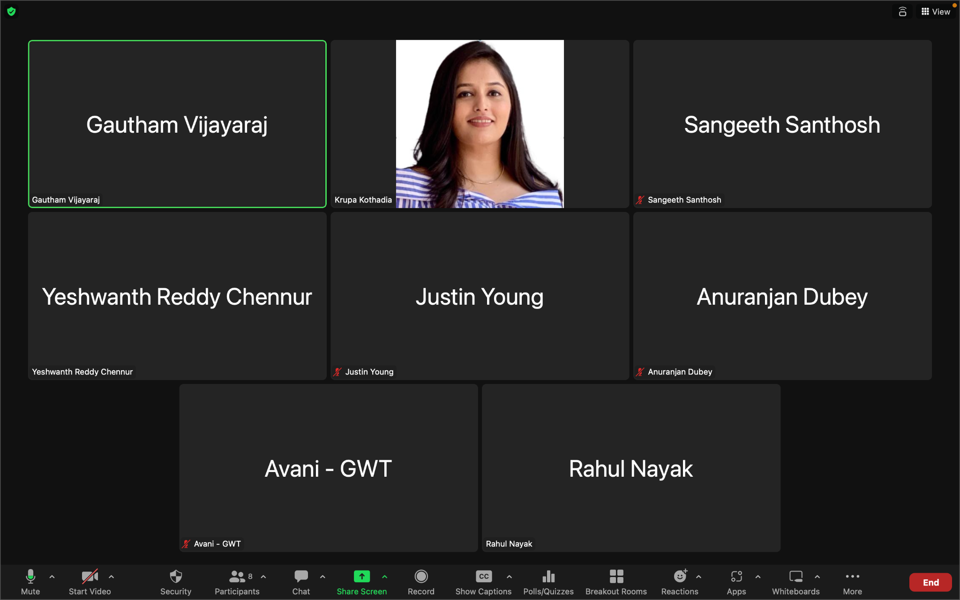

* **Meeting Objective:** Review the outcome of the project presentation, Discuss the requirements for the last group progress report, Revise the group discussion about the approach we followed for responding deficiencies, assign tasks for the final weekly progress report and gantt chart, handle inquiries, share information with team members.
* **Members present:** [Krupaben Kothadia](mailto:kkothadi@asu.edu), [Gautham Vijayaraj](mailto:gvijaya6@asu.edu), [Avani Mundra](mailto:amudra@asu.edu), [Justin Young](mailto:jtyoun15@asu.edu), [Anuranjan Dubey](mailto:adubey37@asu.edu), [Sangeeth Santhosh](mailto:ssantho9@asu.edu), [Rahul Nayak](mailto:rrnayak@asu.edu), [Yeshwanth Reddy Chennur](mailto:ychennur@asu.edu)
* **Members absent:** N/A
* **Reason for absence:** N/A
* **Discussion:**
  + Upon receiving our group's deficiencies, a meeting was conducted.
  + Participants were tasked with acknowledging the validity of their respective deficiencies and providing reasons for their stance.
  + A deficiencies draft was prepared based on the meeting discussions.
  + The draft included details such as deficiency categories, merged deficiency count, valid and invalid deficiencies, 30-word accurate responses for merged deficiencies, and specific responses for individual deficiencies.
  + A table for reviewers was added, assigning deficiency IDs.
  + A total of 21 deficiencies were received and merged into 8 categories.
  + Out of these, 1 deficiency was deemed valid for our project, while 7 were considered invalid.
  + Categories included incorrect deficiencies, incorrect interpretation, unspecified abbreviations, paper age & relevance, incorrect page numbers, blurry images, and lack of information.
  + The deficiencies draft, including the categorized information, is accessible [here](https://chat.openai.com/c/insert_link): [Deficiency_Response_Draft](https://docs.google.com/document/d/1Nd7JojA1KETEjqR_psZWPYGXFhJTgyabg2bO_c3zJAw/edit?usp=drive_link)
  + For Presentation:
    - Team members were tasked with defining the current state of the art in their research sub-domains for the presentation.
    - Major results from individual research efforts were shared, forming the basis for conclusions and recommendations.
    - Discussions about deficiencies in the presentation were derived from the deficiencies draft.
    - The presentation link is available: [Group-1-5_Presentation](https://docs.google.com/presentation/d/12veECEj1T3run7Lf8_eR5fe3gkrPsNYROuGbQ6UXFE4/edit?usp=drive_link)
  + A meeting was held to strategize the writing of the final group progress report.
  + Emphasis was placed on incorporating all necessary details related to planning and discussing group deficiencies, and the group presentation.
* **To Do List:**
  + Each team member will create their individual final report based and will add all the details mentioned in the guideline and based on the work they have done.
  + We also established estimated completion timelines for the presentation, deficiency details draft, last group progress report.
  + Each team member provided all the required details for the presentation and the deficiency draft.
  + [Group-1-5_Presentation](https://docs.google.com/presentation/d/12veECEj1T3run7Lf8_eR5fe3gkrPsNYROuGbQ6UXFE4/edit?usp=drive_link) and [Deficiency_Response_Draft](https://docs.google.com/document/d/1Nd7JojA1KETEjqR_psZWPYGXFhJTgyabg2bO_c3zJAw/edit?usp=drive_link) were created by [Krupaben Kothadia](mailto:kkothadi@asu.edu) and [Gautham Vijayaraj](mailto:gvijaya6@asu.edu).
  + [Work_Distribution_Draft](https://docs.google.com/document/d/1GeTQuPCTc-IWc_gTFRLy4ndWq8LAqnpGHZpEpdxc_t0/edit?usp=drive_link) created by [Krupaben Kothadia](mailto:kkothadi@asu.edu) and [Summary Report](https://docs.google.com/document/d/1XbcMzboJvjf32tEZnhvMYpx2AKLIbhcbtImwqgspNqY/edit?usp=drive_link) created by [Gautham Vijayaraj](mailto:gvijaya6@asu.edu).
  + Last Group Progress Report assigned to: [Krupaben Kothadia](mailto:kkothadi@asu.edu), [Gautham Vijayaraj](mailto:gvijaya6@asu.edu), [Justin Young](mailto:jtyoun15@asu.edu) and [Rahul Nayak](mailto:rrnayak@asu.edu)
* **Next Meeting Scheduled on***: 11/20/2023, 6:30 pm -7:30 pm*

## Classification of Important and Generic Reference Papers

Link to the Reference Documents Classification List: [References_List](https://docs.google.com/document/d/15T-F8te1yxn_htvAxAdAmRKHNw10Ci9SCHduxrQxA4c/edit)

Link to the Not-So-Important Papers Summary document: [Summary_Statement_Not_So_Important_Papers](https://docs.google.com/document/d/1QmxaOqG8rONc0v80Qa2wFGUMXmtyd_5nVvCeJUYJvuM/edit?usp=sharing)

## Approval from the Writing Center

| **Team Member** | **Confirmation** |
| --- | --- |
| Krupaben Kothadia | [Krupa_Writing_Center_Confirmation.png](https://drive.google.com/file/d/1T2lNCffELd2OJwzDJC1Xl5isKRHmBjsv/view?usp=drive_link) |
| Gautham Vijayaraj | [Gautham_Writing_Center_Confirmation.png](https://drive.google.com/file/d/1QrvCRmDiLGXsnag0VgaoHhE-KRLxiuxU/view?usp=drive_link) |
| Avani Mundra | [Avani_Mundra_Writing_Center_Confirmation.png](https://drive.google.com/file/d/1uGJPS7MZcQ929ClZd8bmg-4hPdz4OJre/view?usp=drive_link) |
| Justin Young | [Justin_Young_Writing_Center.png](https://drive.google.com/file/d/1i-v1-qnB5UHbxc2SXAA_fXwH-UkBPEhs/view?usp=drive_link) |
| Sangeeth Santhosh | [Sangeeth_Santhosh_Writing_Center_Confirmation.png](https://drive.google.com/file/d/1W9EuHJuIi6FcidbjQfwFdK-Mi9aIZdFX/view?usp=drive_link) |
| Anuranjan Dubey | [Anuranjan_Dubey_Writing_Center_Confirmation.png](https://drive.google.com/file/d/1X3yRZuiTaRKyZrYN85FJ3IY1peVH101M/view?usp=drive_link) |
| Rahul Nayak | [Rahul_Nayak_Writing_center_confirmation.png](https://drive.google.com/file/d/1ZQT3UgKCBsjz2GzBfarspKJQn6PT7HE5/view?usp=drive_link) |
| Yeshwanth Reddy Chennur | [Yeshwanth_Reddy_Chennur_ Writing Center_ Confirmation.png](https://drive.google.com/file/d/1Bs6vhJJhihQkKoLwllVQSaf3Np2WaKvC/view?usp=drive_link) |

## 

## In-Depth Reports :

| **Area of Study** | **In-Depth Reports** | **Team Members** |
| --- | --- | --- |
| Secure Data Collection Techniques | 7 | [Gautham's Reports](https://drive.google.com/drive/folders/103tAQd_Xbp1c6WvjoMaphRVZYYpl0a-M?usp=drive_link) |
| Data Preprocessing and Feature Engineering | 7 | [Krupa's Reports](https://drive.google.com/drive/folders/1mIlvxSjRUGrNAi83i8M9aH3uPlV74pPl?usp=drive_link) |
| Data Mining Techniques to Handle Multimodal Data | 5 | [Avani's Reports](https://drive.google.com/drive/folders/1fEknqy2Ly_LDNnZdSNppGg_WzLjqbidG?usp=drive_link) |
| Model Security Assurance | 5 | [Justin's Reports](https://drive.google.com/drive/folders/18h07m9wLr3nqPGVhQUozfRKCLGYrmRs9?usp=drive_link) |
| Model Evaluation | 5 | [Sangeeth's Reports](https://drive.google.com/drive/folders/1VFS_OvaD7cuy16C5U6-ldNL9eKs8ykbh?usp=drive_link) |
| Leveraging Machine Learning Models | 5 | [Anuranjan's Reports](https://drive.google.com/drive/folders/1tBtgamDf-9nM-TnDDTZaf5kmYpNPz1i-?usp=drive_link) |
| Data Exploration | 5 | [Rahul's Reports](https://drive.google.com/drive/folders/1d9t6peQJoUu54mJBSW4ckMJJ95BTNcK9?usp=drive_link) |
| Machine Learning Model Security Assurance | 5 | [Yeshwanth's Reports](https://drive.google.com/drive/folders/1BCLS7Vx434_Vofyzb0NivgJPP18PSGDH?usp=drive_link) |

## 

## Weekly Reports :

| **Week Name** | **Report** |
| --- | --- |
| 08/28 | [Week0](https://docs.google.com/document/d/15kbBNp9XjOqkM1fqZjIT-5aGyXUpRX09/edit?usp=drive_link&ouid=116067103181768245745&rtpof=true&sd=true) |
| 09/04 | [Week1](https://docs.google.com/document/d/1iZ5DgHzVsmAB8eKMR8CnwGaaxzCNhm6w/edit?usp=drive_link&ouid=116067103181768245745&rtpof=true&sd=true) |
| 09/11 | [Week2](https://docs.google.com/document/d/14fXhAK9fmBTZoWV5B5JSaXhBInumwiEn/edit?usp=drive_link&ouid=116067103181768245745&rtpof=true&sd=true) |
| 09/18 | [Week3](https://docs.google.com/document/d/1-UAfPDDlV7ia-IM30p0PUgDO-c9KWHW_/edit?usp=drive_link&ouid=116067103181768245745&rtpof=true&sd=true) |
| 09/25 | [Week4](https://docs.google.com/document/d/1-WqZ9-AMMXfbyo-j1DVcBj8FtTS-xLg0/edit?usp=drive_link&ouid=116067103181768245745&rtpof=true&sd=true) |
| 10/02 | [Week5](https://docs.google.com/document/d/1y2By4QiRWC6vRV4oJzz9uO97elpQ4tkw/edit?usp=drive_link&ouid=116067103181768245745&rtpof=true&sd=true) |
| 10/09 | [Week6](https://docs.google.com/document/d/11T4AnIK5a-wc1ZuU3miHMIe8T4xrQeUV/edit?usp=drive_link&ouid=116067103181768245745&rtpof=true&sd=true) |
| 10/16 | [Week7](https://docs.google.com/document/d/1vCnFZ0X4lYV3JxA_sXHH_Dg8LUbjSmDt/edit?usp=drive_link&ouid=116067103181768245745&rtpof=true&sd=true) |
| 10/23 | [Week8](https://docs.google.com/document/d/1yeXn1384VkxJXGU-GSmwdIHVT59V4qkH/edit?usp=drive_link&ouid=116067103181768245745&rtpof=true&sd=true) |
| 10/30 | [Week9](https://docs.google.com/document/d/1dLEDimEJXKvueXyq2bYUQXJWZD85e-Y_iv5Zavtfeeg/edit?usp=drive_link) |
| 11/16 | [Week10](https://docs.google.com/document/d/13vr5g7W7dQLKzj7FhmtONOaFTYzrOfCGSF7RUlZ6xkE/edit?usp=drive_link) |

## Tasks Summary

| **Task Number** | **Task Goal** | **Description of Task** | **Assignee** | **Task Status** | **Evaluator** |
| --- | --- | --- | --- | --- | --- |
| #11.1 | Progress Report, Work-Distribution Draft, Deficiency Response Draft, Presentation | Preparing and approving the progress report, preparing the work-distribution draft, preparing the presentation, preparing the deficiency response draft, addressing the team’s deficiencies, organizing the google drive and meeting. | [Krupaben Kothadia](mailto:kkothadi@asu.edu) | Completed | [Gautham Vijayaraj](mailto:gvijaya6@asu.edu) |
| #11.2 | Progress Report, Summary Report, Deficiency Response Draft, Presentation | Preparing and approving the progress report, preparing the summary report, preparing the presentation, preparing the deficiency response draft, addressing the team’s deficiencies, organizing the google drive and taking meeting notes. | [Gautham Vijayaraj](mailto:gvijaya6@asu.edu) | Completed | [Krupaben Kothadia](mailto:kkothadi@asu.edu) |
| #11.3 | Presentation | Addressing the deficiencies | [Avani Mundra](mailto:amudra@asu.edu) | Completed | [Krupaben Kothadia](mailto:kkothadi@asu.edu) |
| #11.4 | Progress Report, Presentation | Preparing the progress report and addressing the deficiencies | [Justin Young](mailto:jtyoun15@asu.edu) | Completed | [Krupaben Kothadia](mailto:kkothadi@asu.edu) |
| #11.5 | Presentation | Addressing the deficiencies | [Anuranjan Dubey](mailto:adubey37@asu.edu) | Completed | [Krupaben Kothadia](mailto:kkothadi@asu.edu) |
| #11.6 | Progress Report, Presentation | Preparing the progress report and addressing the deficiencies | [Rahul Nayak](mailto:rrnayak@asu.edu) | Completed | [Gautham Vijayaraj](mailto:gvijaya6@asu.edu) |
| #11.7 | Presentation | Addressing the deficiencies | [Sangeeth Santhosh](mailto:ssantho9@asu.edu) | Completed | [Gautham Vijayaraj](mailto:gvijaya6@asu.edu) |
| #11.8 | Presentation | Addressing the deficiencies | [Yeshwanth Reddy Chennur](mailto:ychennur@asu.edu) | Completed | [Gautham Vijayaraj](mailto:gvijaya6@asu.edu) |

## 

## Gantt chart

**Link to the gantt chart:** NA

**Gantt chart updated by**: NA

**Gantt chart approved by**: NA

## Comments

* All group members have been cooperative, showed enthusiasm to work on a project, and have put in an effort to complete their assigned tasks successfully this week.